**Incremental data load from MongoDB:-**

Executed below command on command prompt to run batch

spark-submit --packages org.mongodb.spark:mongo-spark-connector_2.11:2.4.1 D:\NisumCopy\ingestionframework\src\main.py D:\NisumCopy\ingestionframework\src\resources\Config_sample_MOngoDB_Incremental.json

**Configure file:-**

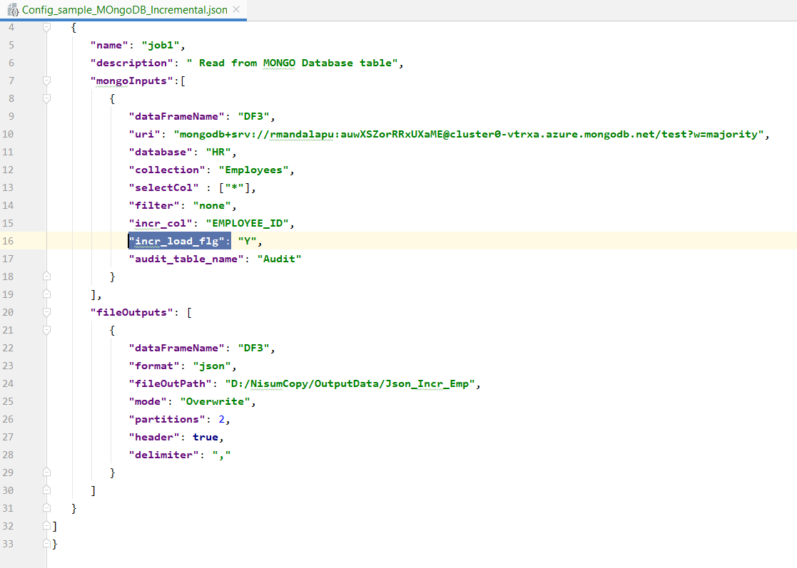

**Status of Batch is:-**

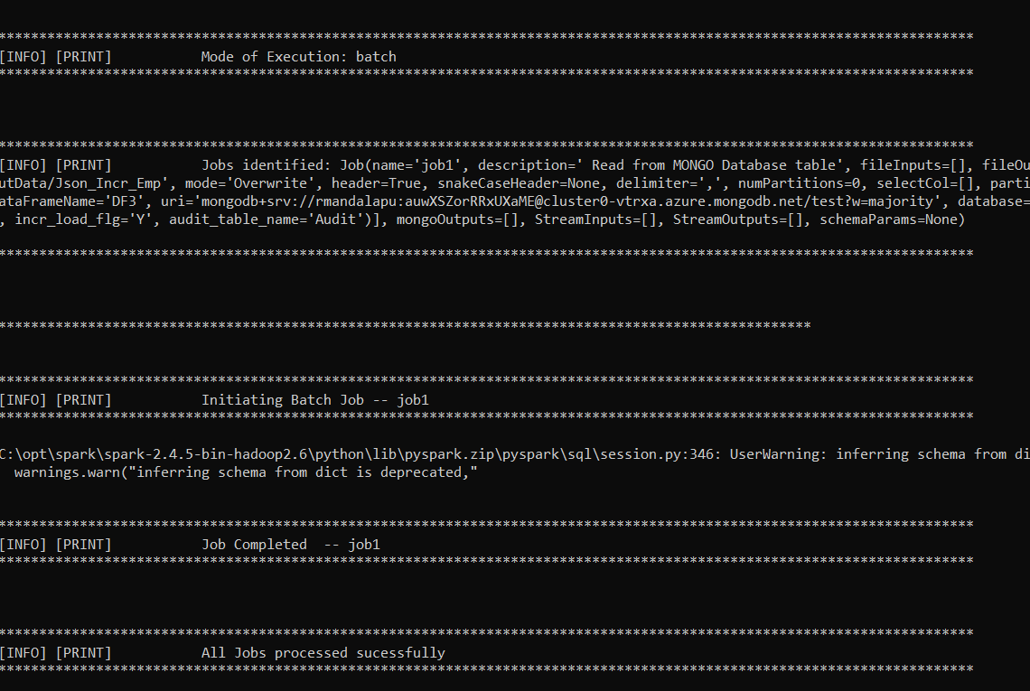

**Result:-**



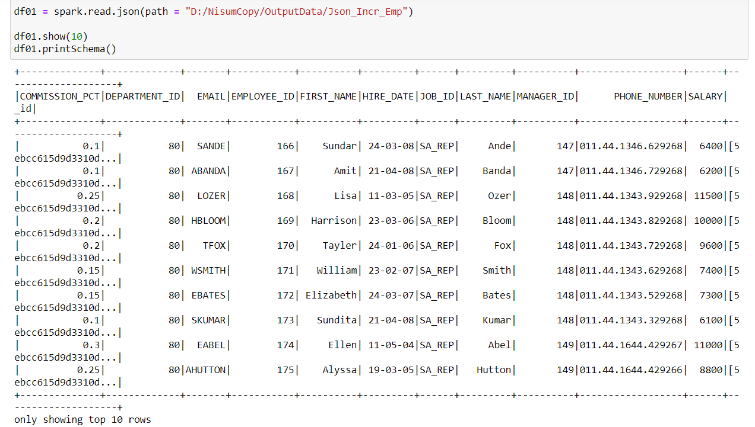

Audit Table update:-

